Payeer for CMS Magento 2.3.0

Copy the app folder via FTP/SSH client to the root of the site.
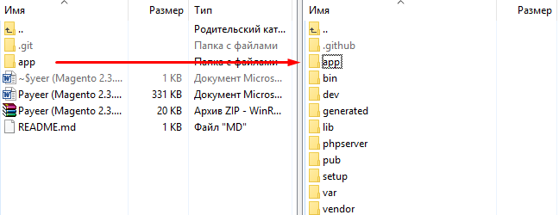
In the command console (for example, Putty) on the server, activate the Payeer module:
php bin/magento module:enable Payeer_Payeer --clear-static-content
php bin/magento setup:upgrade
Expand the static content Magento 2:
php bin / magento setup: static-content: deploy

In the admin panel, go to «Stores → Configuration → Sales → Payment Methods», open the Payeer module settings.
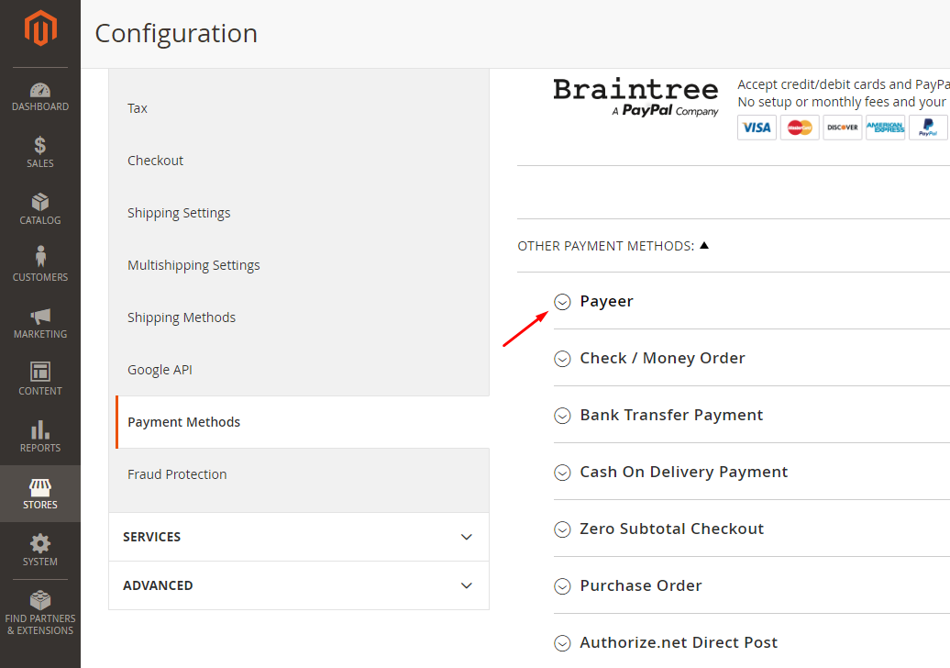
Specify the parameters of the payment system and click «Save Config».
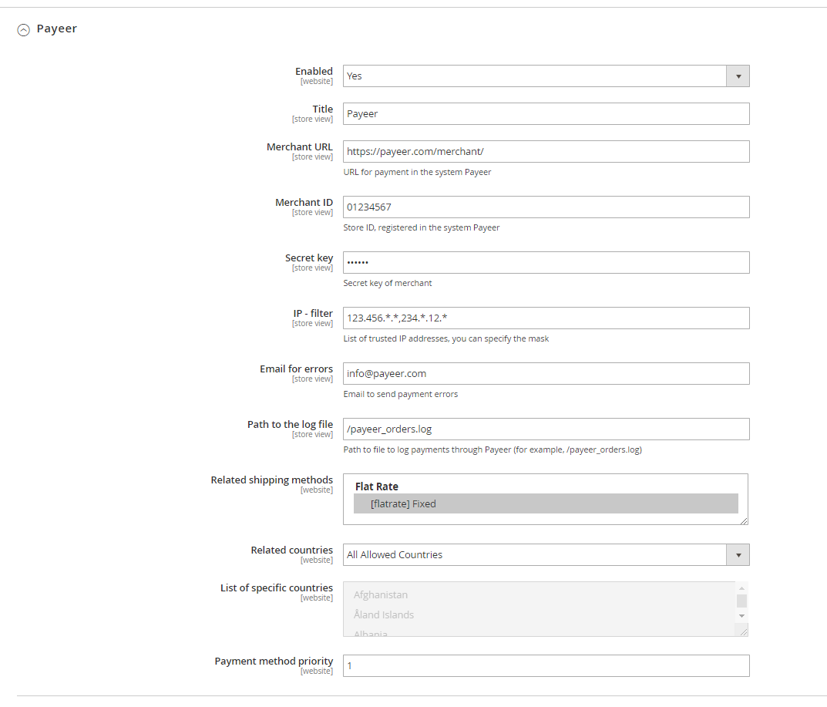
Parameter description:
Merchant URL: the default path to the payment https://payeer.com/merchant/
Merchant ID: ID of your store in the system Payeer.com (can be found in the personal сabinet).
Secret key: the secret key of your store, also issued to you when registering in the system.
Path to the log file: if you specify the path to the file logging, you will be recording information about payments via Payeer.
IP-filter: You can specify the list of all trusted IP addresses of servers, separated by commas. You can also specify a mask instead of the IP address. If the field is empty, checking for trusted IP addresses is not implemented.
For example:
192.168.71.87, 192.165.83.17, 192.178.34.15
Or 192.*.71.87, 192.165.83.*, 192.*.34.15
Or *.*.*.* - all IP addresses available

Email for errors: enter your email address to receive notices in the event of an error of payment. The letter will state the reason and basic information about the payment.

Enter the URL address in the «Account Payeer → Dashboard → Merchant Settings»
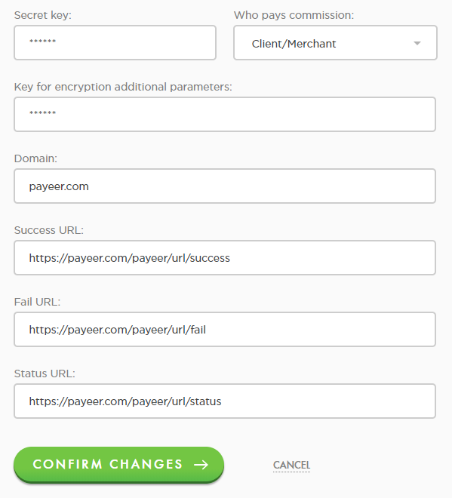

Success URL:
http:// *****/payeer/url/success
Fail URL:
http:// *****/payeer/url/fail
Status URL:
http:// *****/payeer/url/status
Where * * * * * is your domain.
Confirm changes.
Payeer module for CMS Magento 2.3.0 configured.

